**Chapter 1**

Table of Contents

1.2 Silicon 2

1.3 Intrinsic and Extrinsic Materials 3

1.5 n-Type and p-Type Materials 4

1.6 PN Junctions 5

Zener Region 7

1.8 Resistance Levels 9

1.9 Diode Equivalent Circuits 12

1.15 Zener Diodes 14

1.16 Light-Emitting Diodes (LEDs) 15

## 1.2 Silicon

Silicon is a strong crystalline structure containing covalent bonds. A single atom of silicon has 4 valence shell electrons. It forms covalent bonds with 4 other atoms of Si, sharing a single electron with each. Since there are no free electrons, the structure is stable.

In an insulator, the valence and conduction bands are far apart. This makes it difficult for electrons to jump from the valence band to the conduction band, which would have allowed the conduction of electric charge through the material.

In a conductor on the other hand, the valence and conduction bands are close together, making it much easier for electrons to jump from the valence band to the conduction band and begin to conduct charge. As temperature increases, electrons gain energy and are able to perform the jump. For some materials, this process even occurs at room temperature.

## 1.3 Intrinsic and Extrinsic Materials

Pure silicon is said to be intrinsic. A small amount of impurity can be added to the system, such as a single atom of Arsenic in 106 atoms of Silicon, through a process called doping. This new slightly impure material is said to be extrinsic.

Arsenic has 5 valence shell electrons, so the covalent bonding structure will leave one free electron. Arsenic is thus called a donor atom. On the other hand, if Gallium is used, which has 3 valence shell electrons, the bonding will lack one electron. Gallium is called an acceptor atom.

## 1.5 n-Type and p-Type Materials

For pure, intrinsic Si at room temperature, a small number of electrons manage to free themselves from the covalent bonding, leaving behind a hole. The electron-hole pair act as carriers, moving in opposite directions with the hole essentially acting as a positive charge. If there is no voltage applied across the material, this movement is random. If connections are made, electrons will flow towards the positive terminal, causing the holes to flow towards the negative terminal.

For an extrinsic material containing arsenic, the exact same process will take place, except with a much larger number of electrons. Thus, the electrons are called the majority carrier, while the holes are called the minority carrier. Since the majority carrier is negatively charged, such a material is called an n-type material.

p-type materials also exist, such as an extrinsic material containing Gallium. For such materials, the holes are the majority carriers and the electrons are the minority carriers.

## 1.6 PN Junctions

An n-type material is obviously negatively charged while a p-type material is positively charged. Let’s say we somehow manage to stick a block of each type together. Such a combination is known as a PN Junction and the device created is known commonly as a diode.

The edge along which the two blocks touch want to repel each other but cannot. Thus, at RTP, the electrons from the n-type material jump into the holes in the p-type material. This happens without any outside voltage being applied. Thus, for some area from the edge, the region gets neutralized. This region is called the depletion region.

If we now apply a voltage across the material with the negative terminal on the n-type side and the positive terminal on the p-type side, we would expect the electrons to be repelled from the negative terminal towards the positive terminal. This is thus called a forward bias. However, the movement depends on the voltage being applied and is not immediately evident. At 0.7V, the depleted area in the centre begins to shrink, and current starts to flow. As the voltage is increased, current also increases. Eventually, the depleted zone is completely removed and a high current begins to flow. This is the scenario at RTP. For higher temperatures, this movement will begin at a lower voltage. Since we have a voltage source attached that keeps sending electrons, we have no fear of running out of electrons.

On the other hand, if we had reversed the source and attached the positive terminal to the n-type side and the negative terminal to the p-type side, we would increase the area of the depleted region. This is known as a backward bias. Since the majority carriers are not flowing, there is no current.

We can now look at the equation for this:

where is the diode current, is the reverse saturation current, is the diode voltage, is the carrier concentration and is the thermal voltage where . This is called Shockley’s equation.

From the equation we can see that if has a positive value, the value of rises as rises and if then . This agrees with our previous observations.

If has a negative value however, the equation tells us that . This does not agree with our previous understanding that no current flows in backwards bias. This is because we failed to account for the minority charges and only considered the majority charges. There is a small number of positively charged holes in the n-type material and a small number of negatively charged electrons in the p-type material. Under reverse bias conditions, were the majority carriers do not cause any current, these minority carriers will cause a small current. This current is called leakage.

From the forward and backward bias situations, we can create a V-I curve that looks like this:



### Zener Region

If we keep increasing the reverse bias voltage, the minority carriers begin travelling extremely fast. They hit stable atoms, freeing more minority carriers, and making the whole system ionized. At some point, the diode breaks down and the reverse current rises extremely quickly. This current is compared to an avalanche. The diode has entered the Zener region.

The maximum reverse voltage for which the diode does not enter the Zener region is called the Peak Inverse Voltage (PIV) or Peak Reverse Voltage (PRV). The voltage that causes the diode to enter the Zener region is called the Zener Voltage (). Note that the diagram is marked with for Breakdown Voltage instead of . Both are correct.



We can manipulate the point at which the diode enters the Zener region by doping the material. For example, Ge has a much lower breakdown voltage than Si, while GaAs has a much higher one. The breakdown voltage itself is important too. If the diode breaks down at a lower voltage, then the impact is less, which means decreasing the voltage again will return the diode to a stable state. However, if the breakdown region is entered at a high voltage, the impact is much greater. The greater impact damages the diode beyond repair.

Temperature has an effect on the breakdown voltage too. A higher temperature, which reduces the voltage needed for forward bias conduction and increases the reverse current in the reverse bias condition, also pushes the breakdown voltage to a higher point.

## 1.8 Resistance Levels

As the operating point of the diode varies, its resistance also varies. This resistance is also affected by the type of current being used, whether DC or AC.

For DC or static voltage, the resistance at a particular operating point is given by:



With DC current, the input is constant, so the operating point stays fixed. With AC current however, the input varies, which causes the operating point to move within a region. The operating point that would occur with no varying signal is known as the Q-point. The AC or dynamic resistance for the diode is found by drawing a tangent at the Q-point.

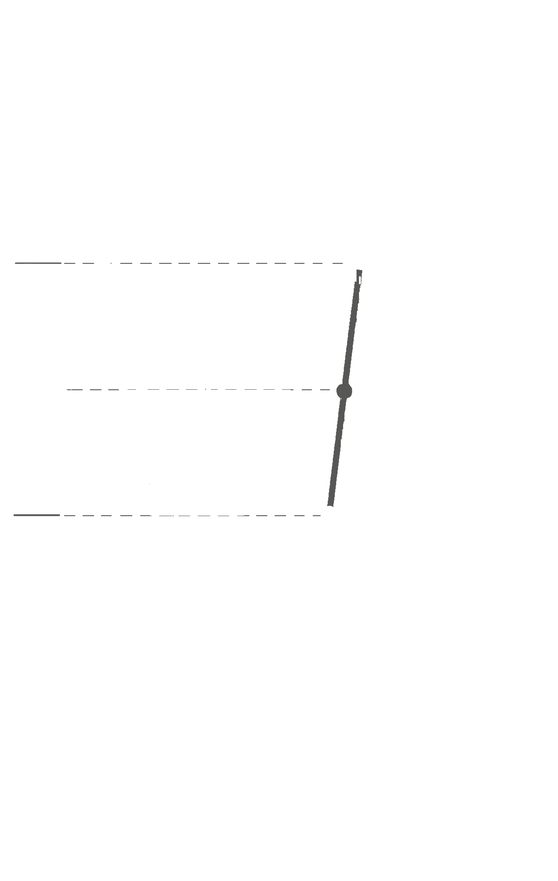

This equation can also be found through calculus (but I’m not sure about how important this part is). We know,

Since generally, ,

At room temperature, .

For ,

This equation is only applicable in the vertical rise section of the curve. Besides the p-n junction, the diode may also have body resistance and contact resistance due to connections. These combined give us

All of this is applicable only for the forward bias region. In the reverse bias region, .

We further have something called the average AC resistance. This is found by using the current and voltage values at two points of the curve. Thus,

## 1.9 Diode Equivalent Circuits

An equivalent circuit is a combination of elements, like resistors, capacitors and inductors, properly chosen to represent the actual characteristics of a device in a particular operating region. Traditional circuit analysis techniques like Thevenin’s theorem or Norton’s theorem cannot be used with circuits containing actual devices like diodes or transistors. If we define an equivalent circuit, we can replace the actual device with the equivalent circuit, thus allowing us to proceed with the analysis techniques.

We will be looking at three types of equivalent circuits, piecewise equivalent circuits, simplified equivalent circuits and ideal equivalent circuits.

For piecewise equivalent circuits, the characteristics of the diode are approximated using straight line segments as shown below. Obviously, the characteristics are not exactly duplicated, especially in the knee region, but a decent first approximation can be obtained.

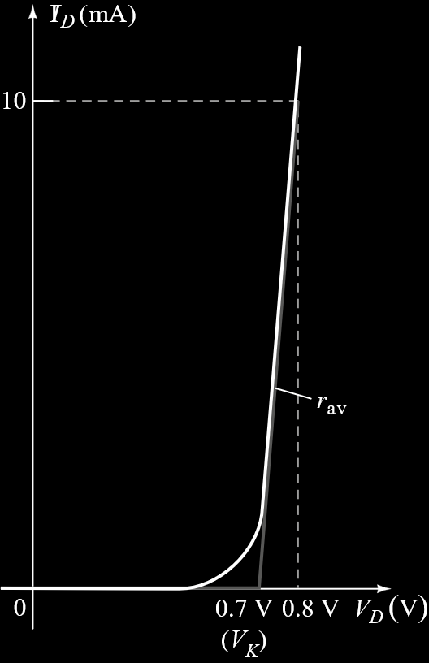

We know that for a silicon semiconductor diode, conduction does not begin until the voltage across the device has reached . To represent this, a battery, , that is opposite in polarity to the circuit is added. Once conduction begins, we have some resistance , for a particular region. Thus, a resistor is added. An ideal diode is also added to simply represent the fact that current can only flow in the forward direction and that the circuit will behave as an open circuit in the reverse direction.



Keep in mind that is not actually an independent voltage source. No reading will be obtained if a voltmeter is attached across the circuit. simply represents the threshold voltage that must be exceeded for conduction to begin. The value of is obtained from the specified operating point, with

In most applications, is small enough to be ignored. This is what the simplified equivalent circuit does. If we do ignore , then it is the same as saying that for the forward biased condition, the diode has a drop of across it for any level of current. No resistance means no curve, thus

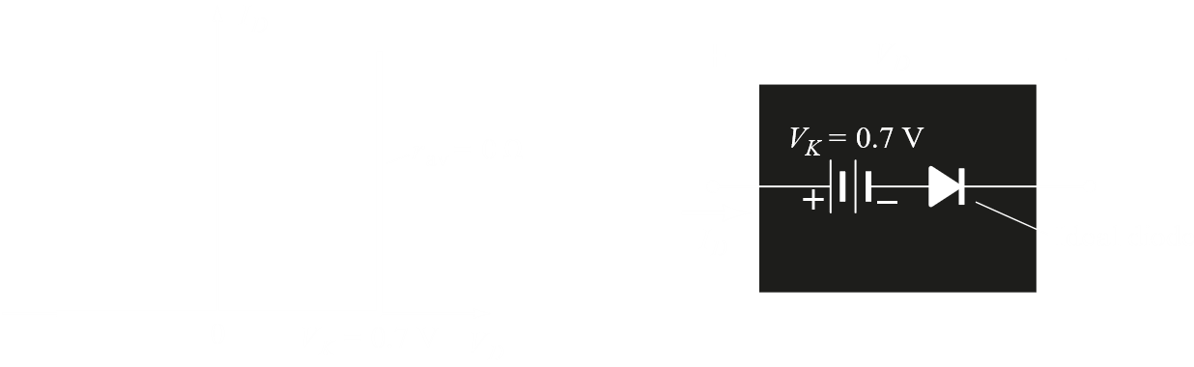

The threshold voltage can even be ignored under certain circumstances, since it is so small. This is the approach taken by the ideal equivalent circuit. If we remove , we are just left with the ideal diode.

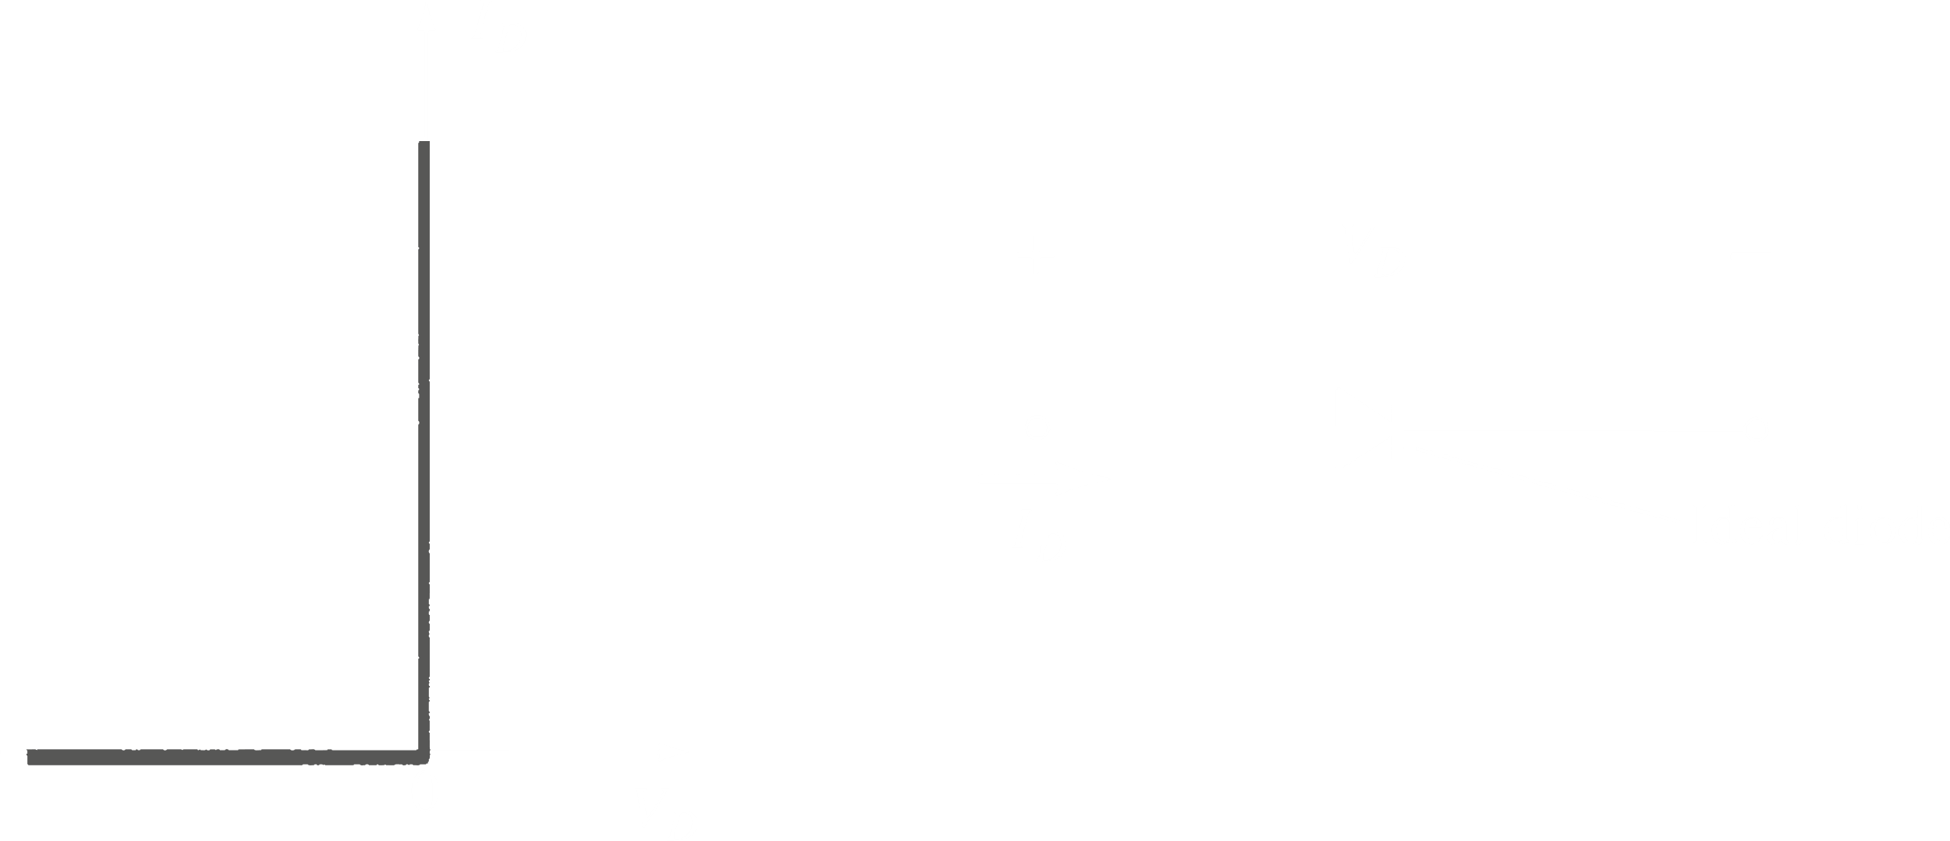

## 1.15 Zener Diodes

A Zener diode allows current in the forward direction like a normal diode, as well as the reverse direction if the voltage is larger than the breakdown voltage.

## 1.16 Light-Emitting Diodes (LEDs)

When forward biased, an LED emits photons. The photons may be of the infrared or visible spectrum. The forward bias voltage is usually in the range of 2V to 5V. The energy of the emitted photons, and thus their colour, varies with the material used in the diode. The voltage required is also affected. For example, diodes made of GaN emit blue light and have a typical forward voltage of 5.0V, while ones made of GaAsP emit red light and have a typical forward voltage of 2.0V.

Diodes can also be packed together to make ICs.